STEP 1: INPUT / OUTPUT DESIGN
Cab Management System

1. INPUT DOCUMENTS (FORMS)
1. CUSTOMER REGISTRATION FORM
Customer ID: _______________________
Name: ______________________________
Phone Number: ______________________
Email: _____________________________
Address: ___________________________
City: ______________________________
Password: __________________________
Date of Registration: _______________

🚕 2. DRIVER REGISTRATION FORM
Driver ID: _________________________
Name: ______________________________
Phone Number: ______________________
License Number: ____________________
Vehicle Type: ______________________
Vehicle Number: ____________________
Experience (years): ________________
Availability Status: ________________
(Admin Use)
Verification Status: ________________

📍 3. RIDE REQUEST FORM
Ride ID: ___________________________
Customer ID: _______________________
Pickup Location: ___________________
Drop Location: _____________________
Ride Type: _________________________
Request Time: ______________________
(System Use)
Assigned Driver ID: ________________
Estimated Fare: ____________________
Ride Status: _______________________

💳 4. PAYMENT FORM
Payment ID: ________________________
Ride ID: ___________________________
Customer ID: _______________________
Amount: ____________________________
Payment Method: ____________________
Payment Status: ____________________
Payment Date: ______________________

⭐ 5. FEEDBACK FORM
Feedback ID: _______________________
Ride ID: ___________________________
Customer ID: _______________________
Driver ID: _________________________
Rating (1–5): ______________________
Comments: __________________________
Date: ______________________________

📊 2. OUTPUT REPORTS
📈 1. DAILY TRIPS REPORT
Date: _____________________________
Ride ID | Customer | Driver | Pickup | Drop | Fare | Status
_______ | ________ | ______ | ______ | ____ | ____ | ______
_______ | ________ | ______ | ______ | ____ | ____ | ______
Total Trips: ______________________
Total Revenue: ____________________

💰 2. DRIVER EARNINGS REPORT
Driver ID: ________________________
Driver Name: ______________________
Ride ID | Date | Fare | Commission | Earnings
_______ | ____ | ____ | __________ | ________
Total Earnings: ___________________

📋 3. CUSTOMER BOOKING HISTORY
Customer ID: ______________________
Ride ID | Date | Pickup | Drop | Driver | Fare | Status
_______ | ____ | ______ | ____ | ______ | ____ | ______

🚦 4. ACTIVE RIDES REPORT
Ride ID | Customer | Driver | Status | Start Time
_______ | ________ | ______ | ______ | __________

⭐ 5. DRIVER RATING REPORT
Driver ID | Driver Name | Average Rating
_______ | ________ | ______

💻 3. TRANSACTION SCREENS
🧑‍💻 1. CUSTOMER ENTRY / EDIT
Customer ID: ______________________
Name: _____________________________
Phone: ____________________________
Email: ____________________________

🚗 2. DRIVER ENTRY / EDIT
Driver ID: ________________________
Name: _____________________________
Vehicle: __________________________
Availability: _____________________

🚖 3. RIDE BOOKING SCREEN
Customer ID: ______________________
Pickup Location: __________________
Drop Location: ____________________
Available Drivers:
Driver ID | Name | Distance | Rating
_______ | ____ | ________ | ______

💳 4. PAYMENT SCREEN
Ride ID: __________________________
Amount: ___________________________
Payment Mode: _____________________

⭐ 5. FEEDBACK ENTRY SCREEN
Ride ID: __________________________
Rating: ___________________________
Comment: __________________________

📘 STEP 2: LIST OF ASSUMPTIONS
Cab Management System

- All customers must register in the system before booking a ride.
- Each customer is assigned a unique Customer ID.
- Drivers must register with valid license and vehicle details before being approved by admin.
- Each driver is assigned a unique Driver ID.
- A driver can be either Available or Not Available at a given time.
- A customer can request only one ride at a time.
- Each ride request contains pickup location, drop location, and request time.
- The system automatically assigns the nearest available driver to the customer.
- If a driver rejects the ride request, the system assigns another available driver.
- Each ride has a unique Ride ID.
- A ride can have the following status:
- Pending
- Accepted
- Ongoing
- Completed
- Cancelled
- Fare is calculated based on distance and ride type.
- Payment can be made using Cash, UPI, or Card.
- Each payment has a unique Payment ID.
- Payment status can be either Paid or Pending.
- After completion of ride, customer can give rating and feedback to driver.
- Ratings are given on a scale of 1 to 5.
- Average rating of driver is calculated based on all feedback received.
- Admin has full control over system including:
- Approving drivers
- Managing users
- Viewing reports
- System maintains complete history of:
- Customer bookings
- Driver trips
- Payments
- One driver can complete multiple rides, but one ride is assigned to only one driver.
- One customer can book multiple rides over time.
- Reports such as daily trips, driver earnings, and customer history are generated automatically.
STEP 2: DATA FLOW
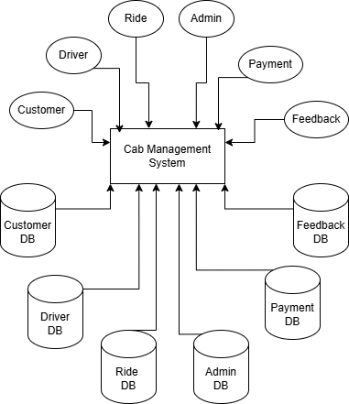

📘 STEP 4: DATA DICTIONARY
Cab Management System
👉 Definition: A data dictionary is a list of all data items with their meanings.

🔤 DATA DICTIONARY
DATA ITEM | DESCRIPTION
ADMIN_ID | Unique identifier for admin
ADMIN_NAME | Name of admin
ADMIN_ROLE | Role of admin
ASSIGNED_DRIVER_ID | Driver assigned to ride
AVAIL_STATUS | Driver availability (Available/Not Available)
AVG_RATING | Average rating of driver
COMMENTS | Feedback comments given by customer
CUST_ADDRESS | Address of customer
CUST_CITY | City of customer
CUST_EMAIL | Email of customer
CUST_ID | Unique identifier of customer
CUST_NAME | Name of customer
CUST_PASSWORD | Password for login
CUST_PHONE | Phone number of customer
DISTANCE | Distance between pickup and drop
DRIVER_ID | Unique identifier of driver
DRIVER_NAME | Name of driver
DRIVER_PHONE | Phone number of driver
DRIVER_EARNINGS | Total earnings of driver
END_TIME | Time when ride ends
EXPERIENCE | Years of driving experience
FARE | Total fare of ride
FEEDBACK_DATE | Date of feedback
FEEDBACK_ID | Unique identifier of feedback
LICENSE_NO | Driving license number
PAYMENT_AMOUNT | Amount paid
PAYMENT_DATE | Date of payment
PAYMENT_ID | Unique identifier for payment
PAYMENT_METHOD | Mode of payment
PAYMENT_STATUS | Status of payment
PICKUP_LOC | Starting location of ride
DROP_LOC | Destination location
RATING | Rating given by customer (1–5)
REG_DATE | Customer registration date
REPORT_DATE | Date of report generation
REQUEST_TIME | Time of ride request
RIDE_ID | Unique identifier of ride
RIDE_STATUS | Status of ride
RIDE_TYPE | Type of ride
START_TIME | Time when ride starts
TOTAL_REVENUE | Total revenue generated
TOTAL_TRIPS | Total number of trips
VEHICLE_NO | Vehicle registration number
VEHICLE_TYPE | Type of vehicle
VERIFY_STATUS | Driver verification status

📘 STEP 5: CROSS-REFERENCE TABLE
Cab Management System
👉 Definition: Shows which data items appear in which forms, reports, or transactions.
📊 CROSS-REFERENCE (KEY ITEMS)
DATA ITEM | CUST FORM | DRIVER FORM | RIDE FORM | PAYMENT FORM | FEEDBACK FORM | REPORTS | SCREENS
CUST_ID | ✓ |  | ✓ | ✓ | ✓ | ✓ | ✓
CUST_NAME | ✓ |  |  |  |  | ✓ | ✓
CUST_PHONE | ✓ |  |  |  |  |  | ✓
CUST_EMAIL | ✓ |  |  |  |  |  | ✓
DRIVER_ID |  | ✓ | ✓ |  | ✓ | ✓ | ✓
DRIVER_NAME |  | ✓ |  |  |  | ✓ | ✓
DRIVER_PHONE |  | ✓ |  |  |  |  | ✓
LICENSE_NO |  | ✓ |  |  |  |  | ✓
VEHICLE_NO |  | ✓ |  |  |  |  | ✓
VEHICLE_TYPE |  | ✓ | ✓ |  |  |  | ✓
AVAIL_STATUS |  | ✓ |  |  |  |  | ✓
VERIFY_STATUS |  | ✓
RIDE_ID |  |  | ✓ | ✓ | ✓ | ✓ | ✓
PICKUP_LOC |  |  | ✓ |  |  | ✓ | ✓
DROP_LOC |  |  | ✓ |  |  | ✓ | ✓
RIDE_TYPE |  |  | ✓ |  |  |  | ✓
REQUEST_TIME |  |  | ✓ |  |  |  | ✓
START_TIME |  |  |  |  |  | ✓
END_TIME |  |  |  |  |  | ✓
DISTANCE |  |  |  |  |  | ✓
FARE |  |  | ✓ | ✓ |  | ✓ | ✓
RIDE_STATUS |  |  | ✓ |  |  | ✓ | ✓
PAYMENT_ID |  |  |  | ✓ |  |  | ✓
PAYMENT_AMOUNT |  |  |  | ✓ |  | ✓ | ✓
PAYMENT_METHOD |  |  |  | ✓ |  |  | ✓
PAYMENT_STATUS |  |  |  | ✓ |  | ✓ | ✓
PAYMENT_DATE |  |  |  | ✓ |  | ✓
FEEDBACK_ID |  |  |  |  | ✓ |  | ✓
RATING |  |  |  |  | ✓ | ✓ | ✓
COMMENTS |  |  |  |  | ✓ |  | ✓
FEEDBACK_DATE |  |  |  |  | ✓ | ✓
AVG_RATING |  |  |  |  |  | ✓
TOTAL_TRIPS |  |  |  |  |  | ✓
TOTAL_REVENUE |  |  |  |  |  | ✓
DRIVER_EARNINGS |  |  |  |  |  | ✓

📘 STEP 6: ENTITIES AND ATTRIBUTES
Cab Management System
👉 Definition: Entities are real-world objects and attributes are their properties.

📊 ENTITIES AND ATTRIBUTES (TABULAR FORM)
ENTITY | ATTRIBUTES
CUSTOMER | CUST_ID (PK), CUST_NAME, CUST_PHONE, CUST_EMAIL, CUST_ADDRESS, CUST_CITY, CUST_PASSWORD, REG_DATE
DRIVER | DRIVER_ID (PK), DRIVER_NAME, DRIVER_PHONE, LICENSE_NO, VEHICLE_TYPE, VEHICLE_NO, EXPERIENCE, AVAIL_STATUS, VERIFY_STATUS, AVG_RATING
RIDE | RIDE_ID (PK), CUST_ID (FK), DRIVER_ID (FK), PICKUP_LOC, DROP_LOC, RIDE_TYPE, REQUEST_TIME, START_TIME, END_TIME, DISTANCE, FARE, RIDE_STATUS
PAYMENT | PAYMENT_ID (PK), RIDE_ID (FK), CUST_ID (FK), PAYMENT_AMOUNT, PAYMENT_METHOD, PAYMENT_STATUS, PAYMENT_DATE
FEEDBACK | FEEDBACK_ID (PK), RIDE_ID (FK), CUST_ID (FK), DRIVER_ID (FK), RATING, COMMENTS, FEEDBACK_DATE
ADMIN | ADMIN_ID (PK), ADMIN_NAME, ADMIN_ROLE

📘 STEP 7: RELATIONSHIPS
Cab Management System
👉 Definition: Relationships show how entities are connected with each other.

📊 RELATIONSHIPS (TABULAR FORM)
RELATIONSHIP NAME | CONNECTED ENTITIES | ATTRIBUTES
CUSTOMER_RIDE | CUSTOMER ↔ RIDE | CUST_ID, RIDE_ID
DRIVER_RIDE | DRIVER ↔ RIDE | DRIVER_ID, RIDE_ID
RIDE_PAYMENT | RIDE ↔ PAYMENT | RIDE_ID, PAYMENT_ID
CUSTOMER_PAYMENT | CUSTOMER ↔ PAYMENT | CUST_ID, PAYMENT_ID
RIDE_FEEDBACK | RIDE ↔ FEEDBACK | RIDE_ID, FEEDBACK_ID, RATING, COMMENTS
DRIVER_FEEDBACK | DRIVER ↔ FEEDBACK | DRIVER_ID, FEEDBACK_ID
CUSTOMER_FEEDBACK | CUSTOMER ↔ FEEDBACK | CUST_ID, FEEDBACK_ID

STEP 8: ER DIAGRAMS
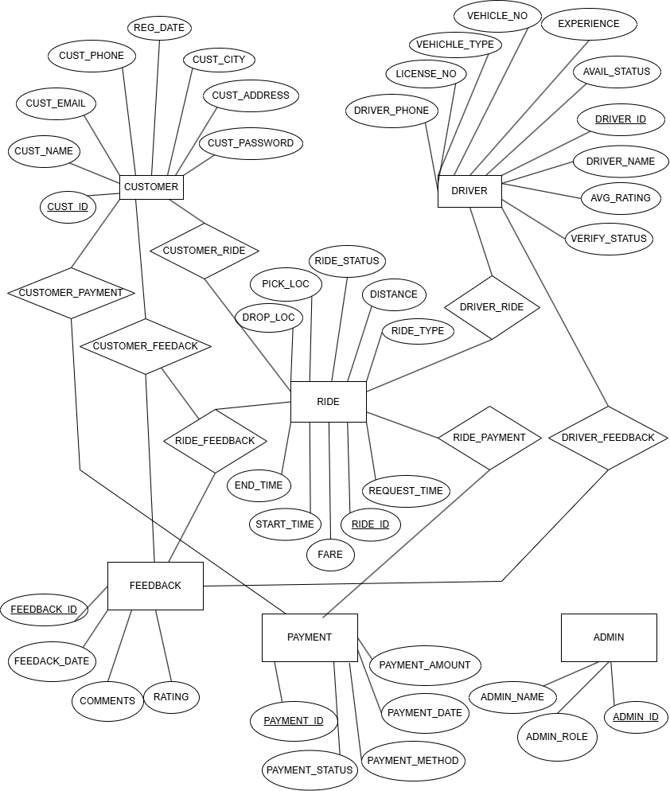
📘 STEP 9: RELATIONAL MODEL
Cab Management System
👉 Definition: Convert the ER Diagram into relational tables using transformation rules.

🧾 CUSTOMER
CUSTOMER
CUST_ID (Primary Key)
CUST_NAME
CUST_PHONE
CUST_EMAIL
CUST_ADDRESS
CUST_CITY
CUST_PASSWORD
REG_DATE

🚗 DRIVER
DRIVER
DRIVER_ID (Primary Key)
DRIVER_NAME
DRIVER_PHONE
LICENSE_NO
VEHICLE_TYPE
VEHICLE_NO
EXPERIENCE
AVAIL_STATUS
VERIFY_STATUS
AVG_RATING

🚖 RIDE
RIDE
RIDE_ID (Primary Key)
CUST_ID (Foreign Key)
DRIVER_ID (Foreign Key)
PICKUP_LOC
DROP_LOC
RIDE_TYPE
REQUEST_TIME
START_TIME
END_TIME
DISTANCE
FARE
RIDE_STATUS

💳 PAYMENT
PAYMENT
PAYMENT_ID (Primary Key)
RIDE_ID (Foreign Key)
CUST_ID (Foreign Key)
PAYMENT_AMOUNT
PAYMENT_METHOD
PAYMENT_STATUS
PAYMENT_DATE

⭐ FEEDBACK
FEEDBACK
FEEDBACK_ID (Primary Key)
RIDE_ID (Foreign Key)
CUST_ID (Foreign Key)
DRIVER_ID (Foreign Key)
RATING
COMMENTS
FEEDBACK_DATE

👨‍💼 ADMIN
ADMIN
ADMIN_ID (Primary Key)
ADMIN_NAME
ADMIN_ROLE

STEP 10: UNIVERSAL RELATION
Cab Management System
👉 Definition: Universal Relation is a single relation containing all attributes used in the database.

📊 UNIVERSAL RELATION (U)
U = { ADMIN_ID, ADMIN_NAME, ADMIN_ROLE, ASSIGNED_DRIVER_ID, AVAIL_STATUS, AVG_RATING, COMMENTS, CUST_ADDRESS, CUST_CITY, CUST_EMAIL, CUST_ID, CUST_NAME, CUST_PASSWORD, CUST_PHONE, DISTANCE, DRIVER_ID, DRIVER_NAME, DRIVER_PHONE, DRIVER_EARNINGS, END_TIME, EXPERIENCE, FARE, FEEDBACK_DATE, FEEDBACK_ID, LICENSE_NO, PAYMENT_AMOUNT, PAYMENT_DATE, PAYMENT_ID, PAYMENT_METHOD, PAYMENT_STATUS, PICKUP_LOC, DROP_LOC, RATING, REG_DATE, REPORT_DATE, REQUEST_TIME, RIDE_ID, RIDE_STATUS, RIDE_TYPE, START_TIME, TOTAL_REVENUE, TOTAL_TRIPS, VEHICLE_NO, VEHICLE_TYPE, VERIFY_STATUS }

📘 STEP 11: NORMALIZATION & FUNCTIONAL DEPENDENCIES
Cab Management System
👉 Definition: This step identifies functional dependencies and converts relations into proper normal forms.

📌 CUSTOMER
CUSTOMER(CUST_ID, CUST_NAME, CUST_PHONE, CUST_EMAIL, CUST_ADDRESS, CUST_CITY, CUST_PASSWORD, REG_DATE)
Functional Dependency: CUST_ID → All other attributes
👉 CUSTOMER is in BCNF.

📌 DRIVER
DRIVER(DRIVER_ID, DRIVER_NAME, DRIVER_PHONE, LICENSE_NO, VEHICLE_TYPE, VEHICLE_NO, EXPERIENCE, AVAIL_STATUS, VERIFY_STATUS, AVG_RATING)
Functional Dependencies: DRIVER_ID → All attributes LICENSE_NO → DRIVER_ID
👉 DRIVER is in BCNF.

📌 RIDE
RIDE(RIDE_ID, CUST_ID, DRIVER_ID, PICKUP_LOC, DROP_LOC, RIDE_TYPE, REQUEST_TIME, START_TIME, END_TIME, DISTANCE, FARE, RIDE_STATUS)
Functional Dependencies: RIDE_ID → All attributes DISTANCE → FARE (derived)
👉 RIDE is in 2NF (FARE is derived, not stored separately if required).

📌 PAYMENT
PAYMENT(PAYMENT_ID, RIDE_ID, CUST_ID, PAYMENT_AMOUNT, PAYMENT_METHOD, PAYMENT_STATUS, PAYMENT_DATE)
Functional Dependency: PAYMENT_ID → All attributes
👉 PAYMENT is in BCNF.

📌 FEEDBACK
FEEDBACK(FEEDBACK_ID, RIDE_ID, CUST_ID, DRIVER_ID, RATING, COMMENTS, FEEDBACK_DATE)
Functional Dependency: FEEDBACK_ID → All attributes
👉 FEEDBACK is in BCNF.

📌 ADMIN
ADMIN(ADMIN_ID, ADMIN_NAME, ADMIN_ROLE)
Functional Dependency: ADMIN_ID → All attributes
👉 ADMIN is in BCNF.

📘 STEP 12: SQL TABLE CREATION
Cab Management System
👉 Definition: SQL statements to create tables based on the normalized design.

🧾 CUSTOMER TABLE
CREATE TABLE CUSTOMER ( CUST_ID VARCHAR(10) PRIMARY KEY,
CUST_NAME VARCHAR(50),
CUST_PHONE VARCHAR(15),
CUST_EMAIL VARCHAR(50),
CUST_ADDRESS VARCHAR(100),
CUST_CITY VARCHAR(30),
CUST_PASSWORD VARCHAR(30),
REG_DATE DATE
);

🚗 DRIVER TABLE
CREATE TABLE DRIVER ( DRIVER_ID VARCHAR(10) PRIMARY KEY,
DRIVER_NAME VARCHAR(50),
DRIVER_PHONE VARCHAR(15),
LICENSE_NO VARCHAR(20) UNIQUE,
VEHICLE_TYPE VARCHAR(20),
VEHICLE_NO VARCHAR(20),
EXPERIENCE INT,
AVAIL_STATUS VARCHAR(20),
VERIFY_STATUS VARCHAR(20),
AVG_RATING FLOAT
);

🚖 RIDE TABLE
CREATE TABLE RIDE ( RIDE_ID VARCHAR(10) PRIMARY KEY,
CUST_ID VARCHAR(10),
DRIVER_ID VARCHAR(10),
PICKUP_LOC VARCHAR(100),
DROP_LOC VARCHAR(100),
RIDE_TYPE VARCHAR(20),
REQUEST_TIME DATETIME,
START_TIME DATETIME,
END_TIME DATETIME,
DISTANCE FLOAT,
FARE FLOAT,
RIDE_STATUS VARCHAR(20),
FOREIGN KEY (CUST_ID)
REFERENCES CUSTOMER(CUST_ID),
FOREIGN KEY (DRIVER_ID)
REFERENCES DRIVER(DRIVER_ID)
);

💳 PAYMENT TABLE
CREATE TABLE PAYMENT ( PAYMENT_ID VARCHAR(10) PRIMARY KEY,
RIDE_ID VARCHAR(10),
CUST_ID VARCHAR(10),
PAYMENT_AMOUNT FLOAT,
PAYMENT_METHOD VARCHAR(20),
PAYMENT_STATUS VARCHAR(20),
PAYMENT_DATE DATE,
FOREIGN KEY (RIDE_ID)
REFERENCES RIDE(RIDE_ID),
FOREIGN KEY (CUST_ID)
REFERENCES CUSTOMER(CUST_ID)
);

⭐ FEEDBACK TABLE
CREATE TABLE FEEDBACK ( FEEDBACK_ID VARCHAR(10) PRIMARY KEY,
RIDE_ID VARCHAR(10),
CUST_ID VARCHAR(10),
DRIVER_ID VARCHAR(10),
RATING INT,
COMMENTS VARCHAR(200),
FEEDBACK_DATE DATE,
FOREIGN KEY (RIDE_ID)
REFERENCES RIDE(RIDE_ID),
FOREIGN KEY (CUST_ID)
REFERENCES CUSTOMER(CUST_ID),
FOREIGN KEY (DRIVER_ID)
REFERENCES DRIVER(DRIVER_ID)
);

👨‍💼 ADMIN TABLE
CREATE TABLE ADMIN ( ADMIN_ID VARCHAR(10) PRIMARY KEY,
ADMIN_NAME VARCHAR(50),
ADMIN_ROLE VARCHAR(30)
);

📘 STEP 13: SQL QUERIES
Cab Management System
👉 Definition: SQL queries to retrieve useful information from the database.

🔍 QUERY 1
Get names of customers and their total number of rides.
SELECT CUST_NAME, COUNT(RIDE_ID) AS TOTAL_RIDES FROM CUSTOMER, RIDE WHERE CUSTOMER.CUST_ID = RIDE.CUST_ID GROUP BY CUST_NAME;

🔍 QUERY 2
Get list of all drivers and their average ratings.
SELECT DRIVER_NAME, AVG(RATING) AS AVG_RATING FROM DRIVER, FEEDBACK WHERE DRIVER.DRIVER_ID = FEEDBACK.DRIVER_ID GROUP BY DRIVER_NAME;

🔍 QUERY 3
Get details of all rides for a particular customer (e.g., C001).
SELECT * FROM RIDE WHERE CUST_ID = 'C001';

🔍 QUERY 4
Get total earnings of each driver.
SELECT DRIVER_ID, SUM(FARE) AS TOTAL_EARNINGS FROM RIDE GROUP BY DRIVER_ID;

🔍 QUERY 5
Get list of all completed rides.
SELECT * FROM RIDE WHERE RIDE_STATUS = 'Completed';

🔍 QUERY 6
Get customers who have made payments greater than 500.
SELECT CUST_ID, PAYMENT_AMOUNT FROM PAYMENT WHERE PAYMENT_AMOUNT > 500;

🔍 QUERY 7
Get all feedback with rating less than 3.
SELECT * FROM FEEDBACK WHERE RATING < 3;

